FINAL TASK OF THE AEM TOOL

TITLE :AUTHOR PORTFOLIO WEBSITE

1. HOME PAGE OF AEM WORK SPACE

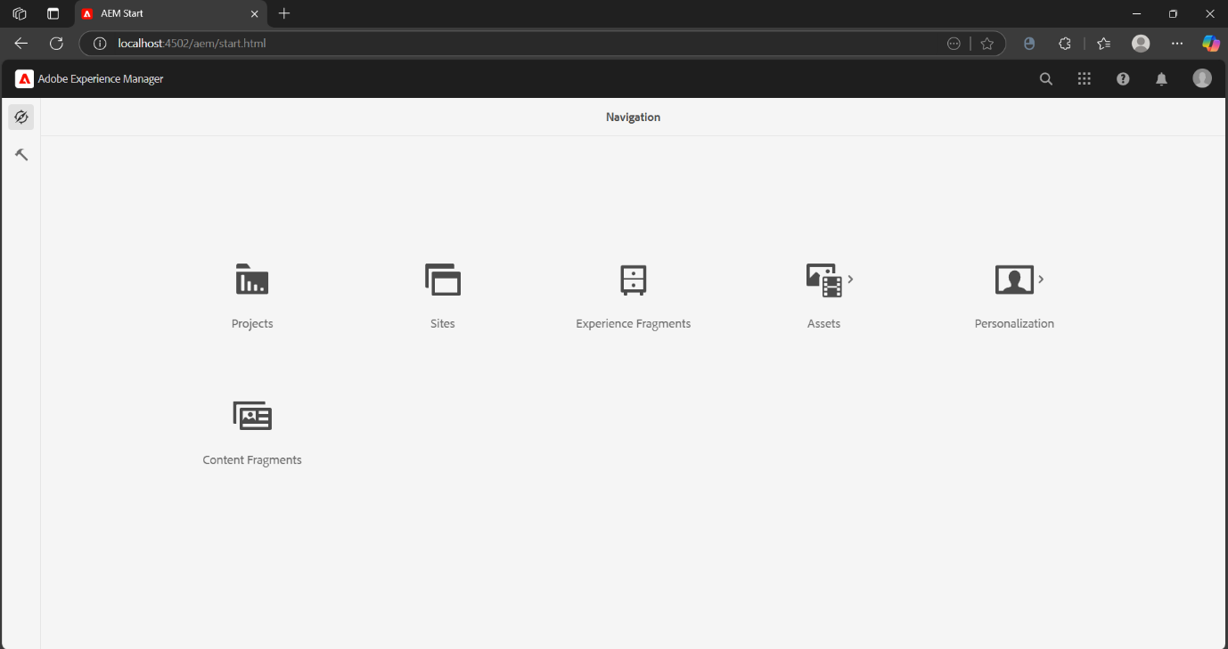

1. REQUIRED PAGES FOR THE SITE

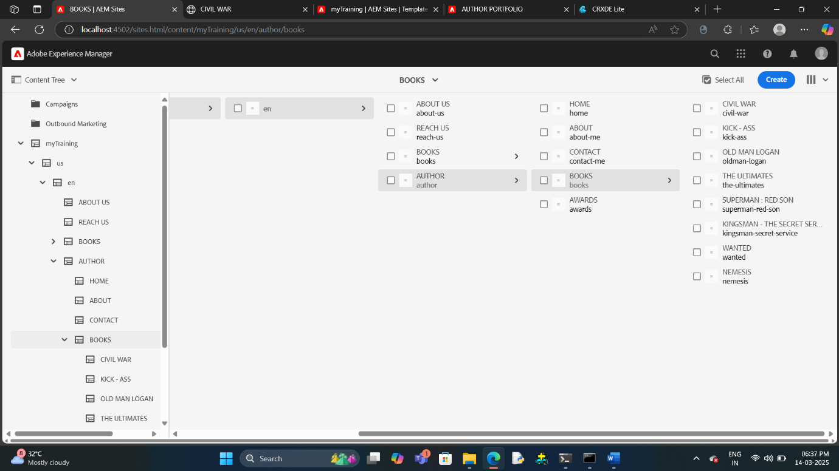

3 .CREATION OF THE DIFFERENT COMPONENTS OF THE WEBPAGE

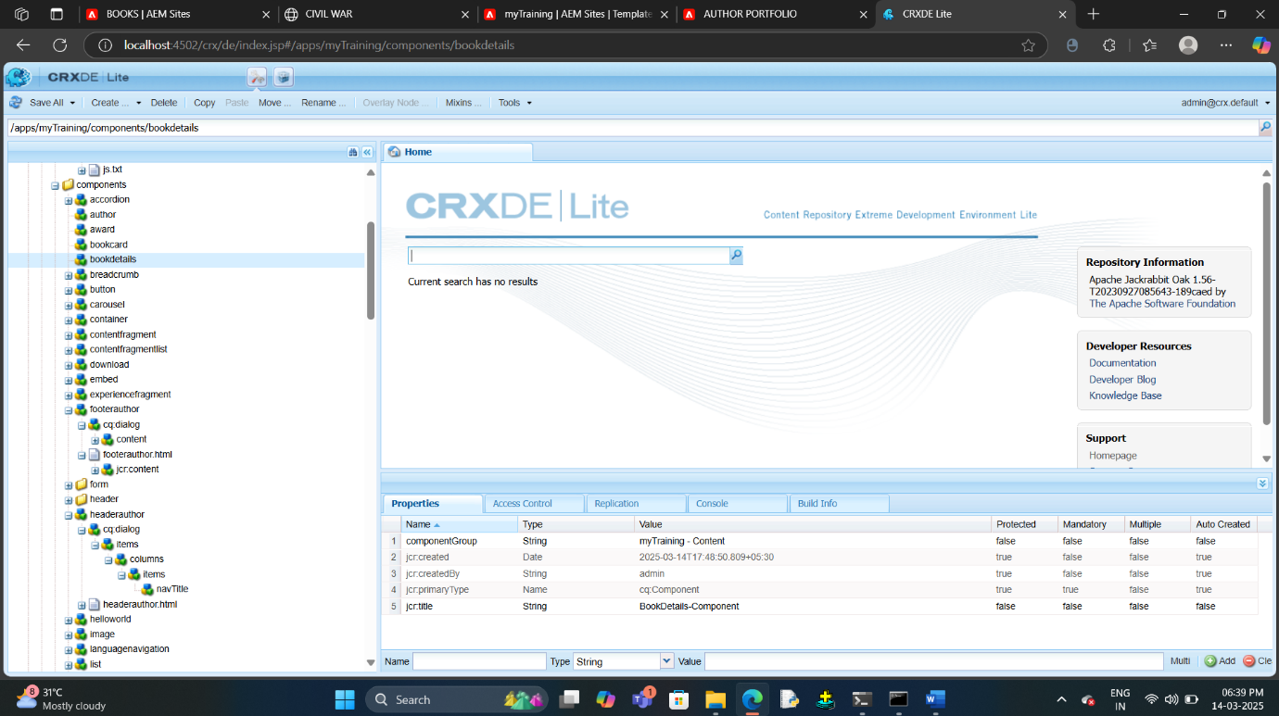

4.CUSTOMIZED HEADER’S CODE WITH STYLING SHEET

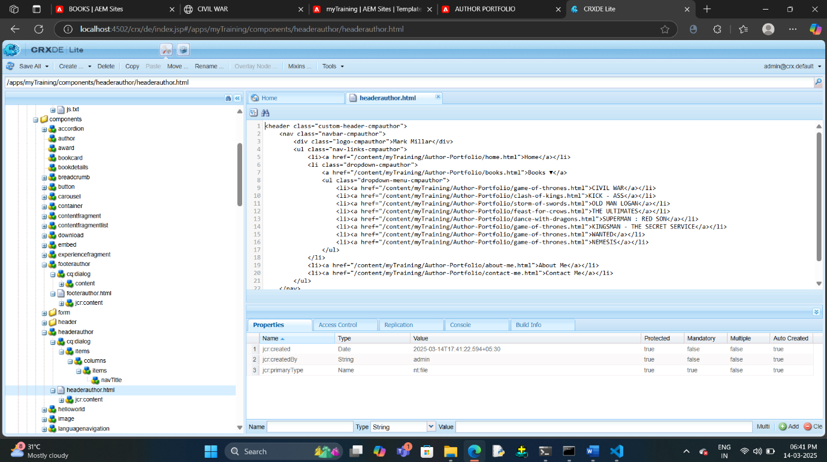

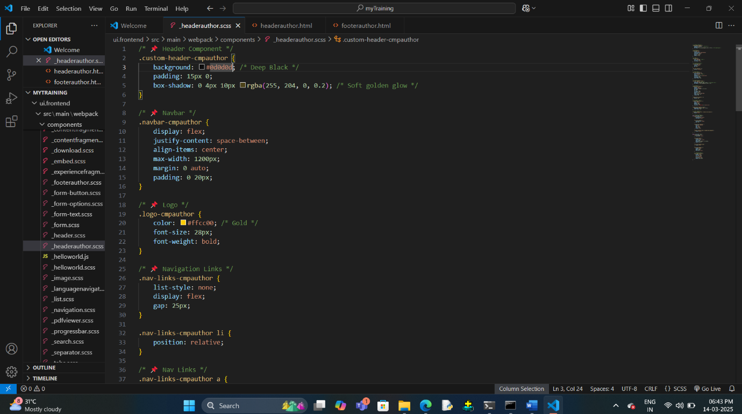

5. CUSTOMZED FOOTER’S CODE WITH STYLING SHEET

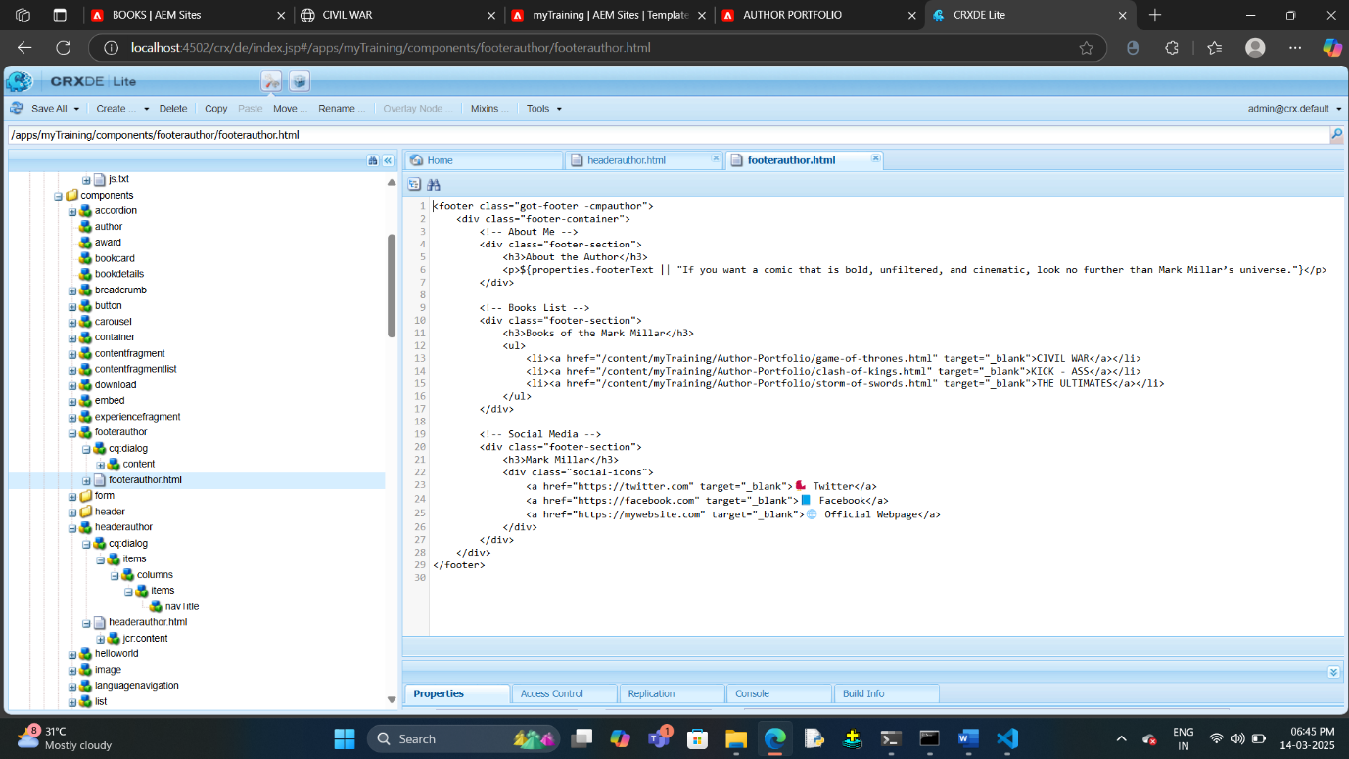

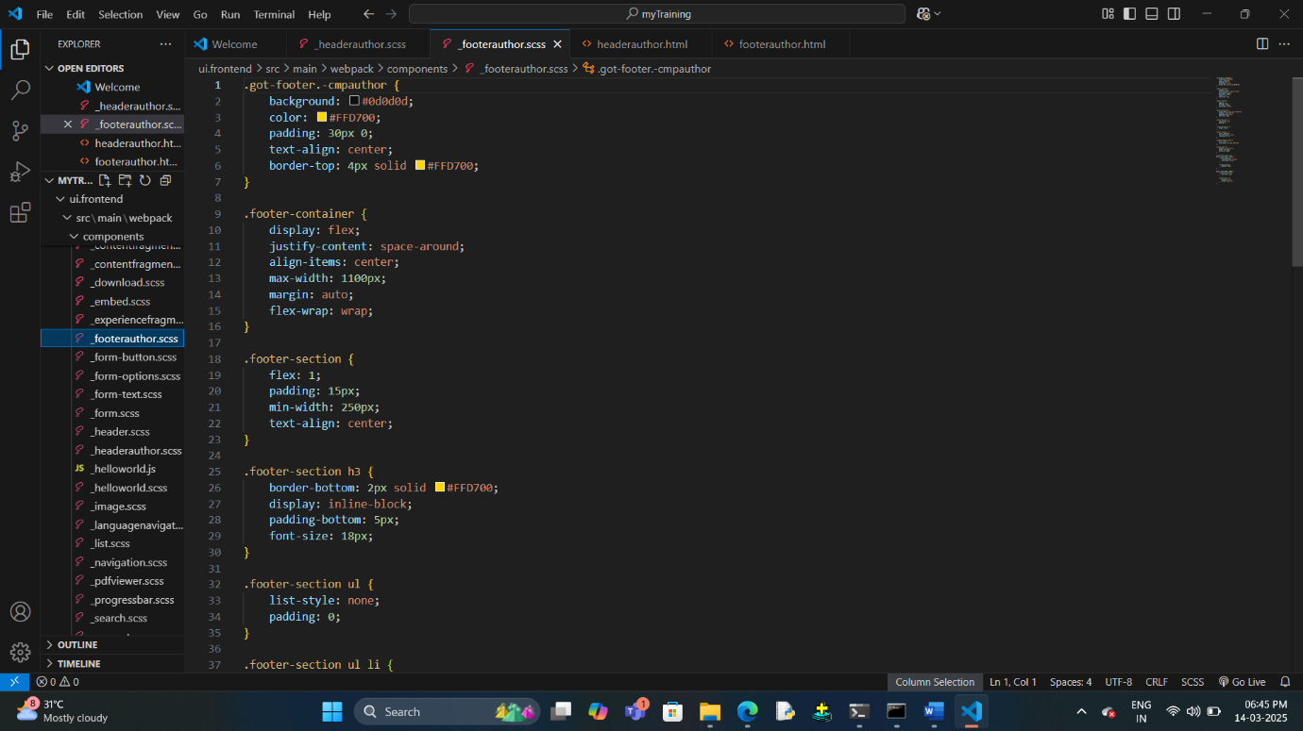

6. ASSETS USED FOR THE PROJECT

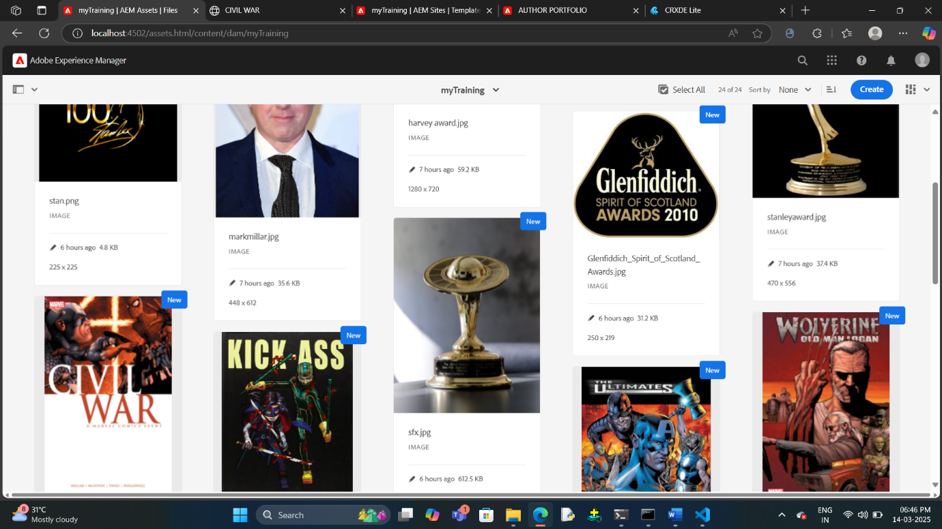

7. OUTPUT FOR THE WEBPAGE

7.1 HEADER WITH DROPDOWN

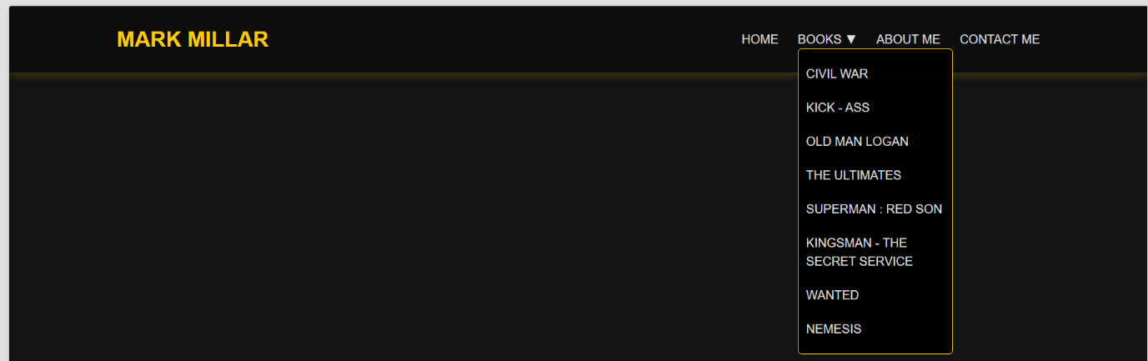

7.2 HOME PAGE

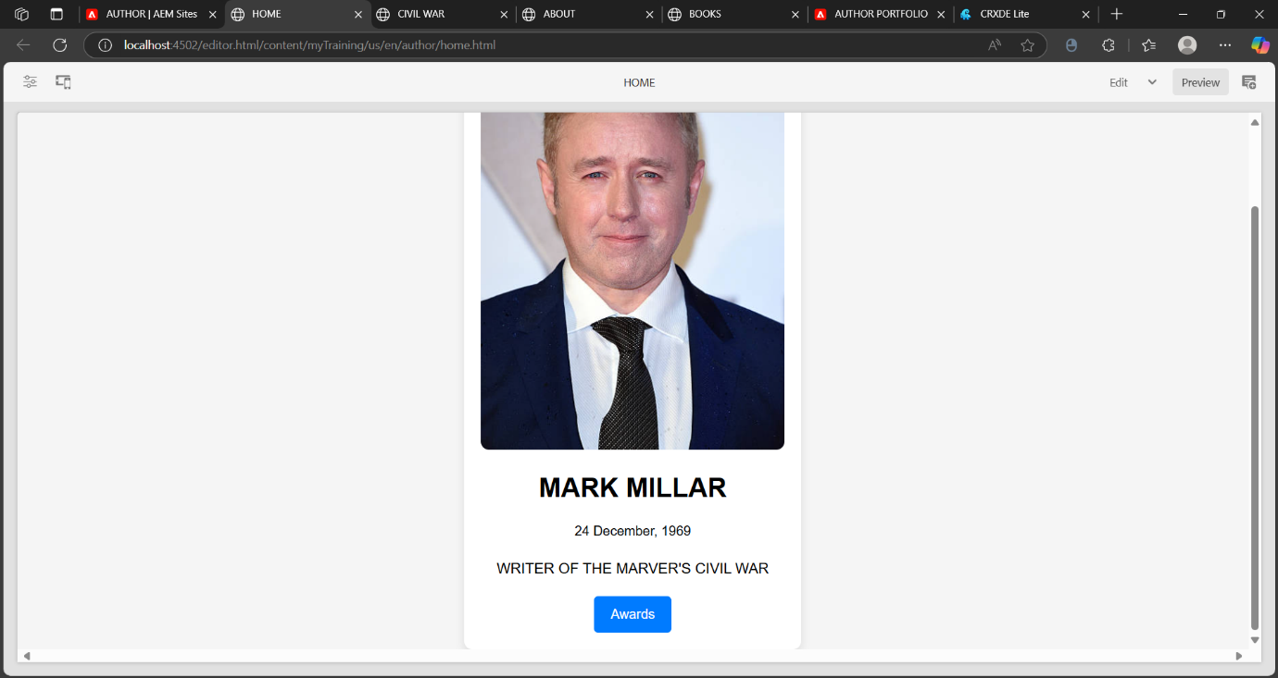

7.3 AWARDS PAGE

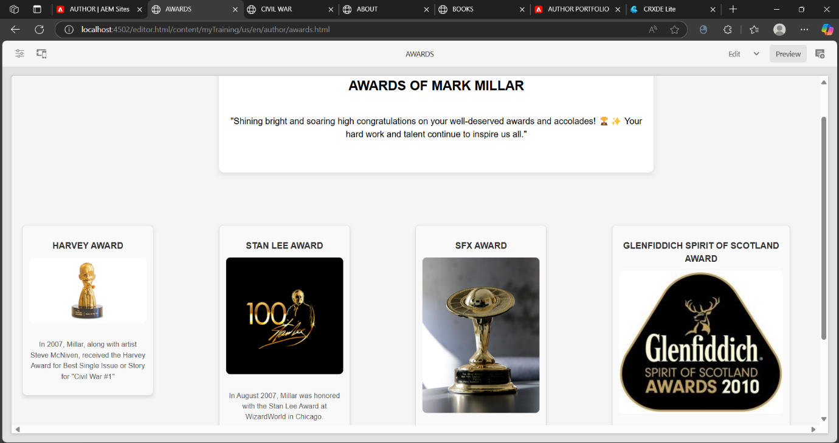

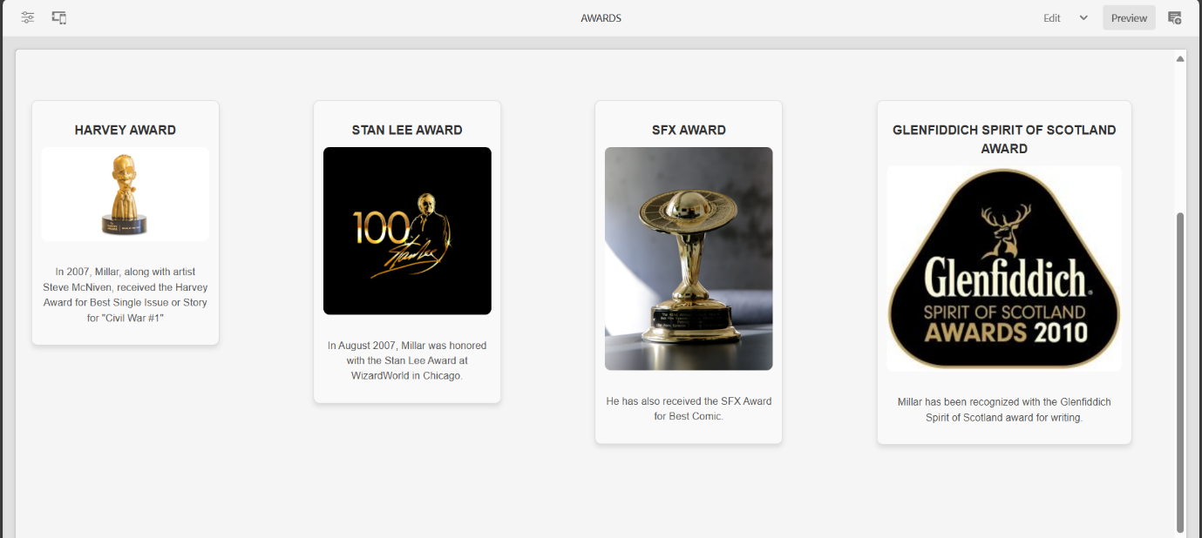

7.4 BOOKS PAGE

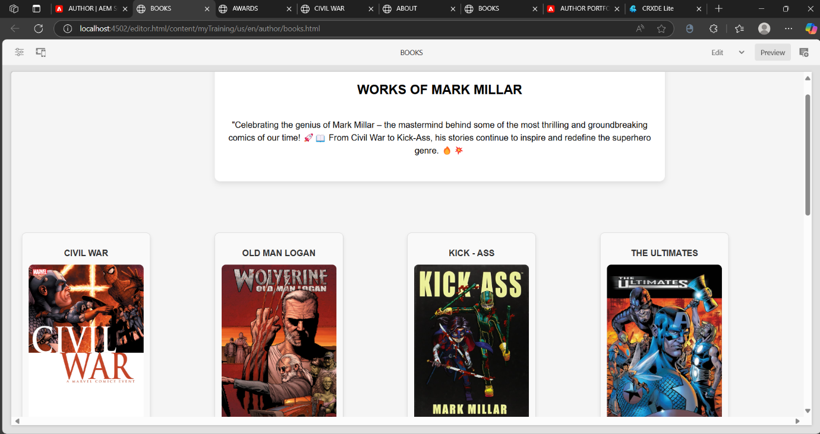

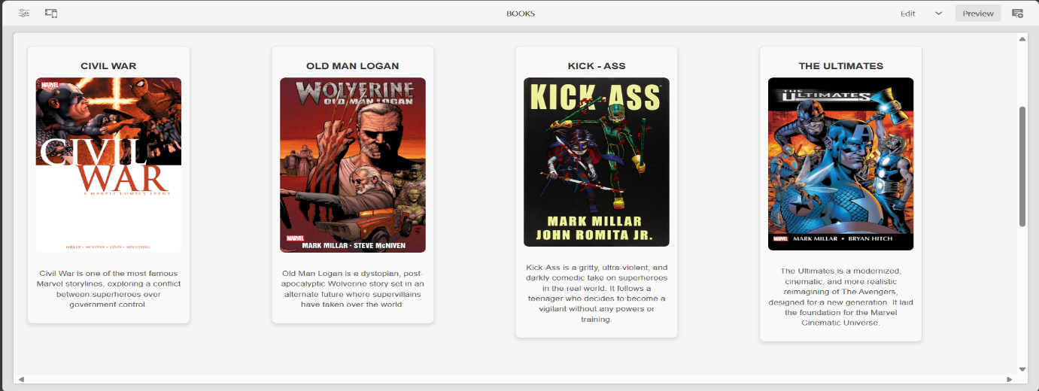

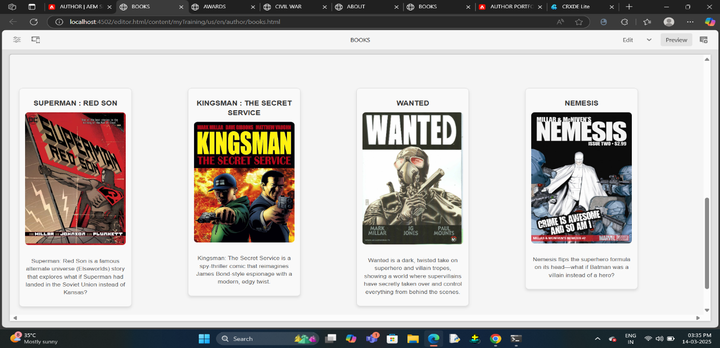

7.5 DESCRITION FOR EACH AND EVERY BOOKS

7.5.1.CIVIL WAR

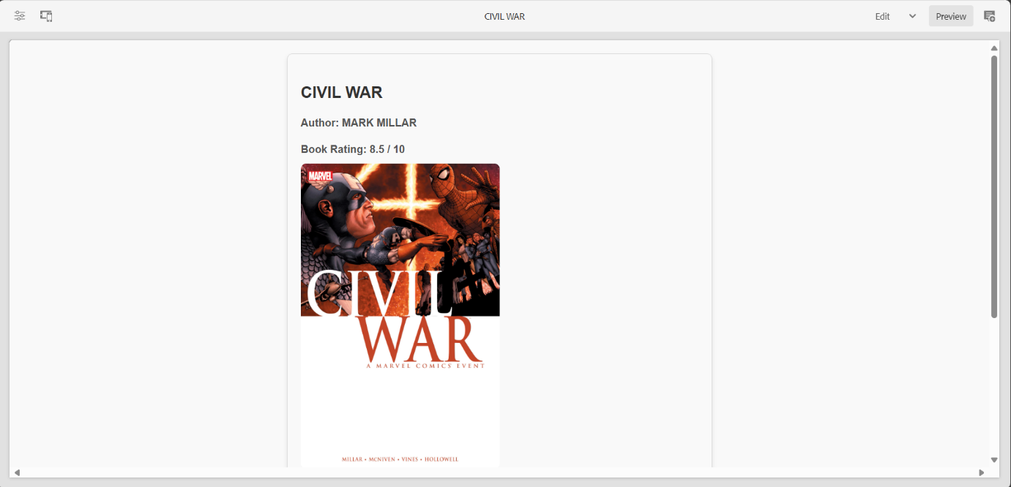

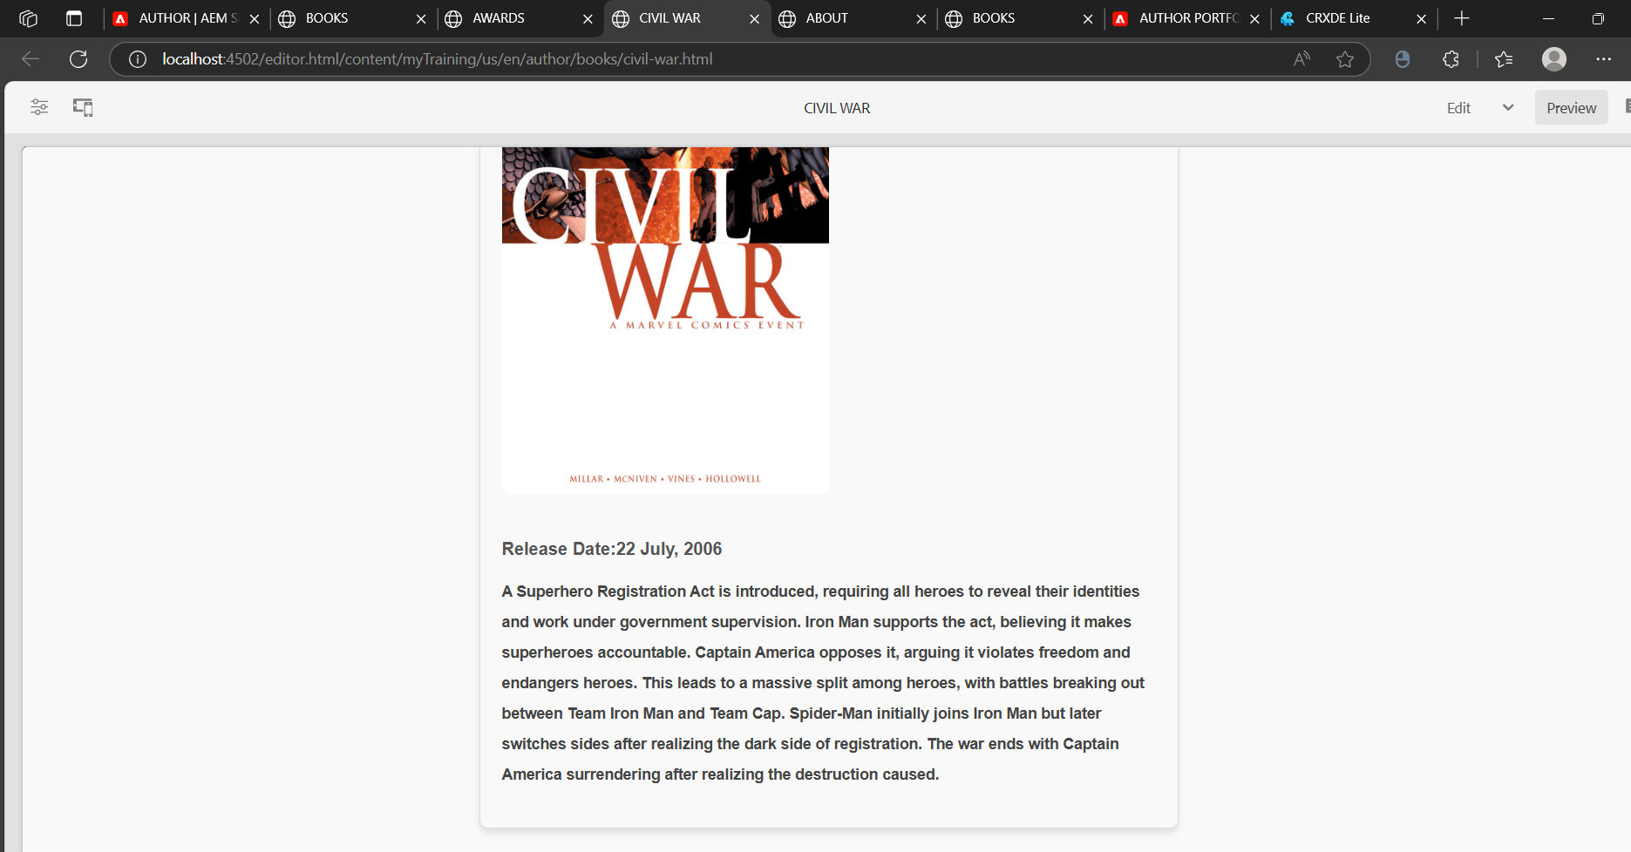

7.5.2.SUPERMAN : RED SON

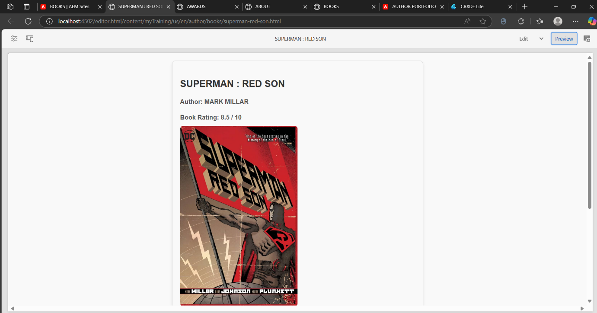

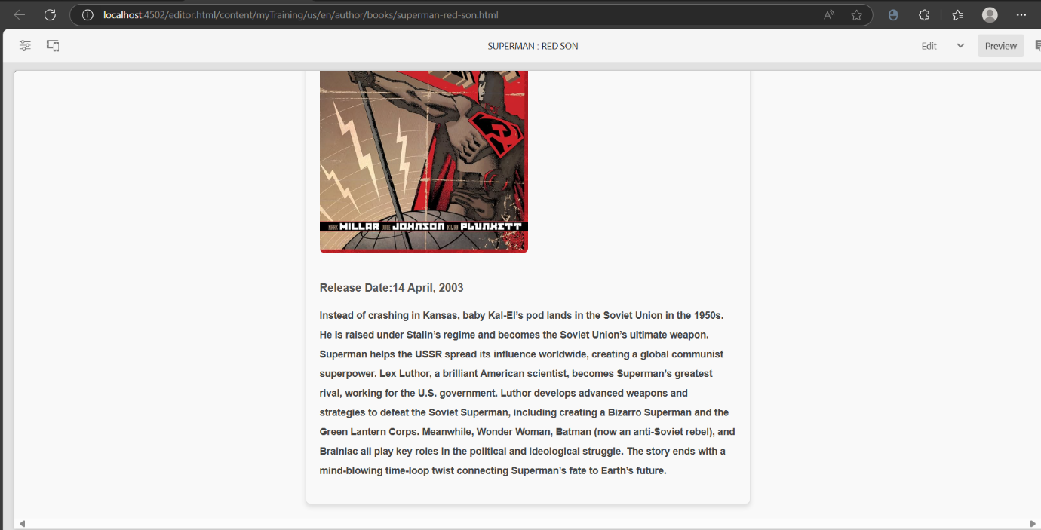

7.5.3.WANTED

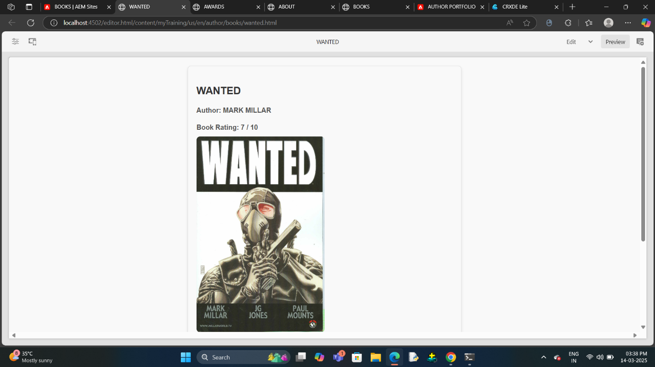

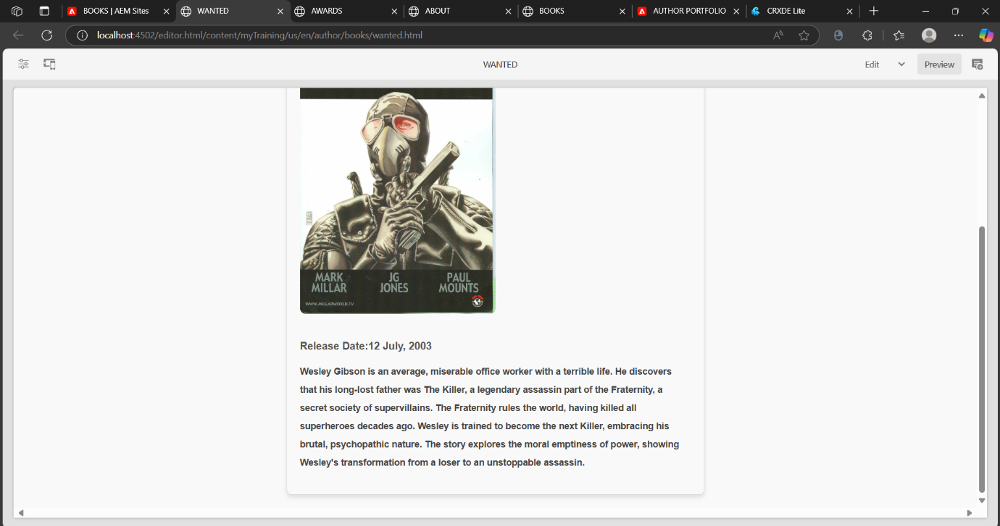

7.6. ABOUT ME PAGE

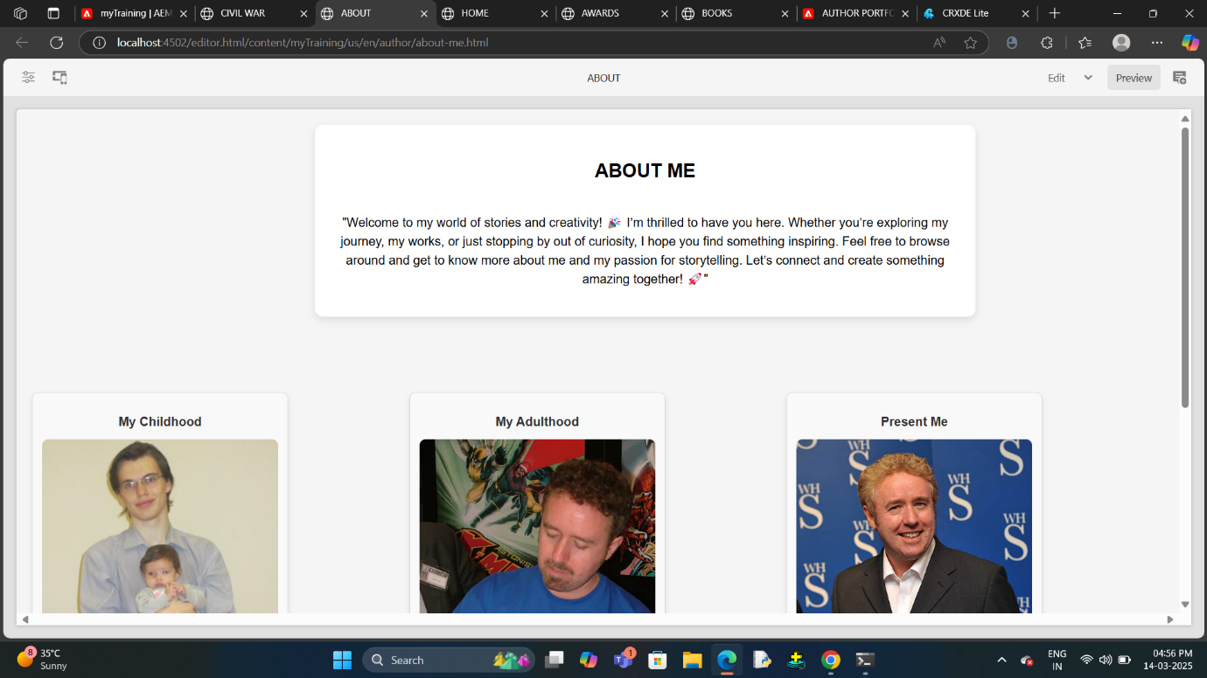

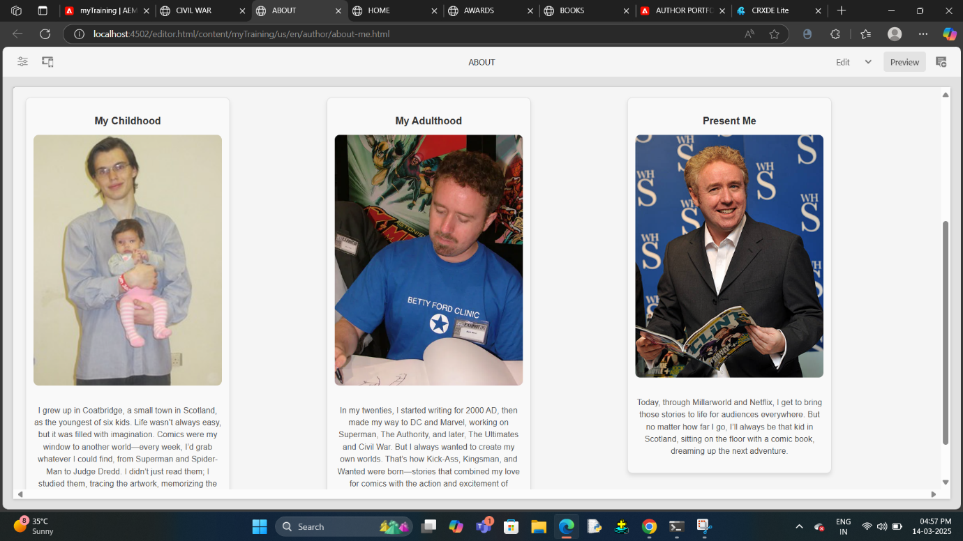

7.7. FOOTER SECTION

